SRT-YOLO11: A Lightweight Network for Shortwave Signal Classification

Under Low SNR Conditions
Shuo Xu^{1,2}, Jianxin Guo^{1,2}, Rui Zhu^{1,3}, Yushuai Zhang^{1,2,*}, Feng Wang^{1,2}, Yaru Li^{1,3}
1 School of Electronic Information, Xijing University, Xi'an 710123, China
2 Xi'an Key Laboratory of Intelligent Perception and Autonomous Navigation for Low-altitude Aircraft, Xi'an 710123, China
3 Xi'an Key Laboratory of High-Precision Industrial Intelligent Vision Measurement Technology, Xi’an 710123, China
* : Correspondence: apacheyu@yeah.net

Abstract
Automatic classification of shortwave communication signals at low signal-to-noise ratios (SNRs) remains challenging because discriminative time-frequency features are readily masked by strong noise, particularly in spectrum monitoring and non-cooperative communication reconnaissance. Here, we propose SRT-YOLO11, a lightweight classification model built upon the YOLO11n-cls backbone. Three complementary modules—Spatial Pyramid Pooling Fast (SPPF), RepVGG-DW, and Triplet Attention—are sequentially embedded after the C2PSA block, enhancing multi-scale time-frequency perception, local texture representation, and noise suppression via cross-dimensional recalibration, respectively. The model is evaluated on a nine-class spectrogram classification task covering typical shortwave signals and a BACKGROUND noise class for false-alarm assessment. Across the SNR range of -20 to -2 dB, SRT-YOLO11 achieves an average accuracy of 36.66% and a macro-averaged F1-score of 35.13%, surpassing the baseline by 0.90 and 0.94 percentage points, respectively, with only 0.18 M additional parameters. The model further outperforms several mainstream lightweight networks in overall performance, and ablation experiments validate the progressive enhancement design. These results demonstrate that SRT-YOLO11 provides an effective and parameter-efficient solution for shortwave signal classification in strong-noise environments.
Keywords: shortwave communication; signal classification; low signal-to-noise ratio; YOLO11; time-frequency spectrogram

Introduction
Shortwave communication offers beyond-line-of-sight propagation and high survivability,and has long been deployed in emergency and maritime communications. As the electromagnetic spectrum becomes increasingly congested, spectrum monitoring and non-cooperative communication reconnaissance impose growing demands on the automatic recognition of intercepted signals. Compared with conventional approaches relying on handcrafted features, deep learning can automatically learn discriminative representations from raw waveforms or time-frequency spectrograms, substantially advancing automatic modulation recognition (AMR) and signal classification [1]. By transforming one-dimensional received signals into two-dimensional time-frequency spectrograms, computer vision models can be further exploited for wideband signal detection, localization, and category discrimination, which has become a prevailing technical paradigm [2]. Among them, the YOLO family, featuring compact architectures and high inference efficiency, has been continuously improved and adapted to spectrogram-based signal recognition [3].
Nevertheless, the identification of shortwave and tactical communication waveforms differs fundamentally from generic AMR. On the one hand, ionospheric propagation introduces multipath and frequency-selective fading that distort the time-frequency structure; on the other hand, different protocols may exhibit highly similar burst structures, subcarrier arrangements, and modulation schemes, and such fine-grained discrepancies are more easily obscured by noise at low SNRs. Prior studies have explored multi-scale convolution and temporal modeling for shortwave protocols such as CLOVER-2000, 2G-ALE, and 3G-ALE [4], while reparameterized lightweight networks have been employed to enhance the robustness of modulation classification under low-SNR conditions [5]. However, end-to-end spectrogram classification across multiple shortwave and tactical waveforms remains underexplored, particularly systematic architectural enhancement and ablation validation of YOLO classification backbones in the extremely low-SNR regime.
To bridge this gap, we propose SRT-YOLO11, an improved classification model that integrates SPPF, RepVGG-DW, and Triplet Attention upon the YOLO11n-cls baseline. The three modules are sequentially embedded after the C2PSA block following a "multi-scale aggregation–local characterization–cross-dimensional recalibration" pipeline, targeting the low-SNR interval of −20 to −2 dB. The main contributions of this work are twofold: (1) A dedicated dataset for shortwave communication signal classification is constructed, covering 2G-ALE, 3G-ALE (BW0–BW4), CLOVER-2000, and LINK11-CLEW; (2) To alleviate the submergence of time-frequency features under low SNRs, a lightweight SRT-YOLO11 model is designed to strengthen multi-scale representation with controlled parameter overhead, and its effectiveness is verified through comparative and ablation experiments.

Related Work
Automatic recognition of wireless signals is a key technique in spectrum monitoring, non-cooperative communication reconnaissance, and intelligent receivers. In recent years, deep learning methods have gradually replaced conventional pipelines that rely on handcrafted features, and the research focus has expanded from early single-modulation recognition to wideband spectrum sensing, multi-signal detection, shortwave protocol identification, and robust classification in complex electromagnetic environments. Existing studies can be roughly divided into three categories: end-to-end modulation recognition based on I/Q sequences, image-based recognition using time-frequency spectrograms, and approaches that employ YOLO, semantic segmentation, or multi-scale detection networks for spectral region detection and signal category discrimination.
In terms of I/Q sequence modeling, recent research has mainly focused on global dependency modeling, lightweight architectures, and robustness to complex channels. Dao et al. proposed VT-MCNet, which introduces the Vision Transformer into automatic modulation classification and enhances signal feature representation through multi-scale convolution and Transformer structures [6]. Shah et al. constructed a dual-stream convolution-GRU-attention network that combines the local feature extraction capability of CNNs with the temporal modeling capability of GRUs for multi-class digital modulation recognition [7]. Tang et al. proposed RepCCNet, a reparameterized causal convolutional network that improves modulation recognition under low-SNR conditions while maintaining a low parameter count [5]. Oikonomou et al. investigated the adaptability of CNNs to hardware non-idealities such as constellation rotation and phase perturbation in automatic modulation classification under phase imperfections [8]. Qu et al. further addressed global feature extraction by combining Transformer and LSTM to model long-term dependencies and improved model generalization through data augmentation [1]. These studies indicate that modulation recognition models have evolved from purely convolutional structures toward hybrid architectures integrating convolution, recurrent networks, attention mechanisms, and Transformers. Compared with generic modulation recognition, shortwave signal recognition faces harsher propagation environments and finer-grained protocol discrepancies. Shortwave channels are significantly affected by ionospheric propagation, multipath fading, frequency-selective fading, and low SNRs, and different protocols may share similarities in bandwidth, burst structure, subcarrier arrangement, and modulation scheme. Jin et al. proposed a multi-scale depthwise separable convolutional model for shortwave signal modulation recognition, which enlarges the receptive field while reducing model complexity, reflecting the demand for lightweight and multi-scale feature extraction in shortwave recognition tasks [9]. Kay et al. studied RF signal analysis and classification from the perspective of permutation entropy, demonstrating that statistical complexity features can still effectively complement deep networks in shortwave pattern recognition [10]. Scholl conducted large-scale classification of 160 shortwave communication signal types, training and validating deep convolutional networks on both synthetic and real received data, reflecting the trend from few-class experiments toward large-scale pattern classification [11]. Cao et al. proposed a multi-scale convolutional GRU model for recognizing shortwave protocols such as CLOVER-2000, 2G-ALE, and 3G-ALE together with their subcarrier modulations, achieving promising results under low-SNR conditions [4]. These works are closely related to our research object and indicate that shortwave protocol recognition requires simultaneous consideration of time-frequency structure, multi-scale texture, and temporal dependency.
In terms of time-frequency spectrogram modeling, researchers typically convert received signals into STFT spectrograms, power spectral density maps, or wideband waterfalls, and then employ computer vision models for detection, segmentation, or classification. Vagollari et al. proposed an end-to-end wideband signal recognition framework that integrates signal detection, localization, and modulation classification in wideband spectrograms, demonstrating the effectiveness of deep learning for wideband signal recognition [2]. Huynh-The et al. converted 5G NR and LTE signals into spectrograms and adopted a ConvNet for semantic-segmentation-based spectrum sensing [12]. Nguyen et al. further improved DeepLabV3+ by introducing adaptive atrous spatial pyramid pooling and attention mechanisms to enhance the segmentation of 5G/LTE signal regions [13]. Subsequently, SRNet and RPMSN continued along the semantic segmentation line, improving the recognition accuracy of signal regions in spectrograms through multi-scale feature extraction, resolution preservation, and attention mechanisms [14], [15]. Owing to their outstanding engineering deployability and inference efficiency, the YOLO family has become a dominant tool in object detection. Comar applied YOLOv5 to modulation recognition on the WBSig53 dataset, exploring the relationships among wideband signal detection, modulation family classification, and specific modulation recognition [16]. Kang et al. employed YOLOv8 for joint detection and classification of communication and radar signals in congested RF environments, verifying the capability of detection models to handle overlapping multi-signal and dynamic spectrum scenarios [17]. Quach and Reese applied YOLO to RF signal classification in power spectral density maps, highlighting the advantages of spectrograms over raw I/Q data in terms of human interpretability and localization capability [18]. Regarding more recent model improvements, Spec-YOLO designed lightweight feature fusion and an improved feature pyramid structure for 5G NR and LTE spectrogram recognition [3]; Wang et al. incorporated non-local attention and SimAM into YOLO to strengthen global context representation for broadband signal identification [19]; and DFN-YOLO improved narrowband signal detection in wideband scenarios through a deformable feature enhancement network [20]. These studies demonstrate that object detection has become an important technical route for spectrogram-based signal detection and recognition.
In summary, recent research has demonstrated the effectiveness of deep learning for communication signal recognition in terms of I/Q sequence modeling, time-frequency spectrogram classification, wideband spectrum detection, and shortwave protocol identification. Nevertheless, two limitations remain: first, most automatic modulation classification studies target generic modulation types and pay relatively little attention to shortwave communication waveforms; second, the application of the YOLO family in spectrum-related tasks mainly concentrates on object detection, while research on spectrogram-based signal classification remains limited. Motivated by these observations, this work focuses on time-frequency spectrogram classification of shortwave communication signals and constructs the lightweight SRT-YOLO11 classification model to address the limited classification accuracy under low-SNR conditions.

Methods

Dataset Description
The experimental dataset consists of four typical shortwave and tactical communication signals,namely 2G-ALE,3G-ALE,CLOVER-2000,and LINK11
-CLEW. Since the 3G-ALE physical layer defines five burst waveforms (BW0–BW4), the final task comprises eight signal classes: 2G-ALE, 3G-ALE_BW0, 3G-ALE_BW1, 3G-ALE_BW2, 3G-ALE_BW3, 3G-ALE_BW4, CLOVER-2000, and LINK11-CLEW.To enable false-alarm evaluation, an additional BACKGROUND class containing pure noise is introduced, which forms the classification task together with the eight signal classes. All signal segments are uniformly sampled, truncated, and normalized, and then converted into time-frequency spectrograms for subsequent model training and testing.
To transform the one-dimensional time-series signal into a two-dimensional representation suitable for network processing, the short-time Fourier transform (STFT) is adopted to generate time-frequency spectrograms. Let the discrete received signal be x[n], the window function be w[n], and the hop size be H; the STFT is then expressed as:
$$\text{X}\left(\text{m}\text{,}\text{k}\right)\text{=}\sum_{\text{n}\text{=0}}^{\text{N}\text{−1}}{\text{x}}\left[\text{n}\right]\text{w}\left[\text{n}\text{−}\text{mH}\right]{\text{e}}^{\text{−}\text{j}\text{2}\text{πknN}}$$ | (1)
where $\text{X}\left(\text{m}\text{,}\text{k}\right)$ denotes the complex spectral coefficient at the m-th time frame and the k-th frequency bin, x[n] is the input one-dimensional discrete signal sequence, n is the sample index, N is the number of FFT points (i.e., the window length), H is the hop size between adjacent frames, k is the frequency bin index, and j is the imaginary unit.
After obtaining the complex spectrum, its magnitude is taken and converted to a logarithmic scale to enhance the visibility of weak-energy regions in the spectrogram:
$$S\left(\text{m}\text{,}\text{k}\right)\text{=}\text{20 }\log_{10}(\left|\text{X}\left(\text{m}\text{,}\text{k}\right)\right|+ϵ)$$ | (2)
where $S\left(\text{m}\text{,}\text{k}\right)$ denotes the log-magnitude value at the m-th time frame and the k-th frequency bin, |X[m, k]| is the magnitude of the complex spectral coefficient, and ε is a small positive constant added to avoid taking the logarithm of zero.
The spectrogram is subsequently normalized and mapped to an RGB pseudo-color image as the network input. Specifically, the STFT uses NFFT = 256; the normalized log-magnitude spectrogram is mapped to pseudo-color RGB and uniformly resized to 320×320 as the input of the classification network. This representation explicitly presents the temporal burst structure, frequency occupancy, and energy distribution of shortwave signals in a two-dimensional image, enabling the model to learn discriminative features among different communication waveforms from image textures and global morphology.

2G-ALE
The second-generation automatic link establishment (2G-ALE) technology follows the MIL-STD-188-141A standard and adopts 8FSK modulation, aiming to automatically select, establish, and maintain shortwave communication links in complex and time-varying ionospheric channel environments.
2G-ALE is centered at 1500 Hz, with eight tone frequencies equally spaced from 750 Hz to 2500 Hz at 250 Hz intervals. To reduce the bit error rate caused by adjacent-frequency decision errors, the mapping between the eight frequencies and 3-bit symbols is established via Gray coding. The key property of Gray code is that adjacent codewords differ by only one bit; therefore, when the receiver misjudges a tone as an adjacent one, at most one bit error is introduced. Within the n-th symbol period, the transmitter selects the tone frequency according to the input bit combination, and the generated 8FSK signal can be expressed as:
$$\text{s}\left(\text{t}\right)\text{=Acos}\left(\text{2π}{\text{f}}_{{\text{k}}_{\text{n}}}\text{t+}{\text{ϕ}}_{\text{n}}\right)\text{, n}{\text{T}}_{\text{s}}\text{≤t<}\left(\text{n+1}\right){\text{T}}_{\text{s}}$$ | (3)
where A is the signal amplitude, T is the symbol duration, f_n is the tone frequency selected for the n-th symbol, and φ_0 is the initial phase.

3G-ALE
3G-ALE is a comprehensive upgrade of 2G-ALE. Its physical-layer waveform adopts 8PSK modulation with a carrier frequency of 1800 Hz and a symbol rate of 2400 Baud. Another important feature of 3G-ALE is the introduction of the BWx (Burst Waveform) family, which is used in different stages of communication. The standard defines five burst waveforms:
BW0 used in the link establishment stage, carrying all 3G-ALE protocol data units (PDUs);BW1 used for traffic management, control, and resource scheduling;BW2 used for high-speed data transmission;BW3 used for low-rate, robustness-enhanced data transmission;BW4 used for the automatic repeat request (ARQ) acknowledgment process.
The baseband modulation of 3G-ALE adopts 8PSK, in which each symbol carries 3 bits of information through eight equally spaced phase states. The eight constellation points are uniformly distributed on the unit circle, and the complex representation of the k-th constellation point is:
$${\text{c}}_{\text{k}}\text{=}{\text{e}}^{\text{j2πk/8}}\text{, k=0,1,…,7}$$ | (4)
Expanding into in-phase and quadrature components,${\text{c}}_{\text{k}}\text{=}{\text{I}}_{\text{k}}\text{+j}{\text{Q}}_{\text{k}}$,where ${\text{I}}_{\text{k}}\text{=cos}\left(\text{2πk/8}\right)$ and ${\text{Q}}_{\text{k}}\text{=sin}\left(\text{2πk/8}\right)$,The transmitter encodes every 3 bits into a phase symbol ${\text{c}}_{{\text{k}}_{\text{n}}}$ and after pulse shaping, the complex baseband signal is:
$$\tilde{\text{s}}\left(\text{t}\right)\text{=}\sum_{\text{n}}{{\text{c}}_{{\text{k}}_{\text{n}}}}\text{g}\left(\text{t−n}{\text{T}}_{\text{s}}\right)$$ | (5)
where g(t) is the pulse-shaping function and $T_{s}$ is the symbol period. This complex baseband signal carries the complete amplitude and phase information, and its real and imaginary parts correspond to the I and Q baseband waveforms, respectively:
$$\tilde{\text{s}}\left(\text{t}\right)\text{=}\sum_{\text{n}}{{\text{c}}_{{\text{k}}_{\text{n}}}}\text{g}\left(\text{t−n}{\text{T}}_{\text{s}}\right)$$ | (6)
After IQ quadrature up-conversion to the carrier frequency f_c, the actual RF transmitted signal is:
$$\text{s}\left(\text{t}\right)\text{=}{\text{s}}_{\text{I}}\left(\text{t}\right)\text{cos}\left(\text{2π}{\text{f}}_{\text{c}}\text{t}\right)\text{−}{\text{s}}_{\text{Q}}\left(\text{t}\right)\text{sin}\left(\text{2π}{\text{f}}_{\text{c}}\text{t}\right)$$ | (7)

CLOVER-2000
CLOVER-2000 is a family of modem waveform techniques designed for high-frequency (HF) radio systems and belongs to the third-generation general-purpose shortwave data transmission protocols. It adopts a multi-tone parallel orthogonal modulation structure, in which the signal is formed by superimposing multiple subcarriers in the time-frequency domain. The center frequencies of the eight subcarriers cover 625 Hz to 2375 Hz with a constant spacing, and the ordered set of center frequencies is:
$$f_{m}=625+(m−1)×250Hz, m=1,2,...8$$ | (8)
In the time domain, one single-tone pulse is transmitted in each time slot, and eight pulses constitute one frame. The transmission order of subcarriers across time slots follows a predefined interleaving sequence, so that subcarriers adjacent in frequency are dispersed in time to achieve frequency diversity gain. After interleaving, the transmit frequencies of successive time slots are [625, 1625, 875, 1875, 1125, 2125, 1375, 2375] Hz.
$$\text{s}\left(\text{t}\right) \text{=} {\text{s}}_{\text{I}}\left(\text{t}\right)\text{cos}\left(\text{2π}{\text{f}}_{\text{c}}\text{t}\right) \text{−} {\text{s}}_{\text{Q}}\left(\text{t}\right)\text{sin}\left(\text{2π}{\text{f}}_{\text{c}}\text{t}\right)$$ | (9)
The composite transmit signal of the n-th frame can be expressed as:
$$s^{\left(n\right)}\left(t\right)=\sum_{k=1}^{8}{Re}\left\{d_{k}^{\left(n\right)}⋅g\left(t−\left(k−1\right)T_{p}\right)⋅e^{j2πf_{σ\left(k\right)}t}\right\}$$ | (10)
where $d_{k}^{\left(n\right)}∈ℂ$ is the complex modulation symbol on the m-th time slot of the l-th frame, f_m is the subcarrier frequency corresponding to that slot, and g(t) is the pulse-shaping function. During continuous transmission, the complete CLOVER-2000 signal is formed by concatenating all frames along the time axis:
$$s\left(t\right)=\sum_{n}{s^{\left(n\right)}}\left(t−nT_{\text{frame}}\right)$$ | (11)
where n is the frame index and $T_{\text{frame}}$ is the frame length.

LINK11-CLEW
LINK11-CLEW is a tactical data link waveform based on multi-tone parallel transmission, whose baseband signal consists of 16 tones. Among them, the first tone at 605 Hz serves as the Doppler correction tone and carries no modulation information; the 2nd to 15th tones are data tones ranging from 935 Hz to 2365 Hz with 110 Hz spacing; and the 16th tone at 2915 Hz is used for data transmission and frame synchronization. Within the n-th symbol period, the synthesized baseband signal is modeled as:
$$\text{s}\left(\text{t}\right)\text{=}{\text{A}}_{\text{0}}\text{cos}\left(\text{2π}{\text{f}}_{\text{0}}\text{t}\right)\text{+}\sum_{\text{k=1}}^{\text{15}}{{\text{A}}_{\text{k}}}\text{cos}\left(\text{2π}{\text{f}}_{\text{k}}\text{t+}{\text{ϕ}}_{\text{k}}^{\left(\text{n}\right)}\right)\text{, n}{\text{T}}_{\text{s}}\text{≤t<}\left(\text{n+1}\right){\text{T}}_{\text{s}}$$ | (12)
where ${\text{f}}_{\text{0}}$= 605 Hz is the Doppler reference tone frequency, ${\text{A}}_{\text{0}}$ is its constant amplitude, ${\text{A}}_{\text{k}}$ is the amplitude of the i-th data tone, and ${\text{ϕ}}_{\text{k}}^{\left(\text{n}\right)}$ is the absolute phase carried by that data tone in the n-th symbol period. The data tones adopt π/4-DQPSK modulation, in which each input dibit is mapped to a phase increment, and the absolute phase is recursively updated through differential encoding:
$${\text{ϕ}}_{\text{k}}^{\left(\text{n}\right)}\text{=}{\text{ϕ}}_{\text{k}}^{\left(\text{n−1}\right)}\text{+Δ}{\text{ϕ}}_{\text{k}}^{\left(\text{n}\right)}$$ | (13)
The key advantage of differential encoding is that demodulation does not require recovering the absolute carrier phase; the receiver only needs to compute the phase difference between adjacent symbols, which provides inherent robustness against the carrier phase drift and frequency offset that are common in shortwave channels.
At the data organization level, LINK11-CLEW transmits data in frames. Each frame contains 30 bits, consisting of 24 information bits and 6 Hamming parity-check bits, and two frames form a complete 48-bit codeword. The transmitter divides the 30 bits of each frame into 15 groups of 2 bits, which are mapped onto the 15 data tones through serial-to-parallel conversion and transmitted in parallel within a single symbol period. Each burst consists of a preamble segment, a phase reference segment, and a data segment: the preamble is used for signal detection and symbol synchronization; the phase reference segment establishes the initial reference for differential demodulation with predefined phases; and the data segment carries the encoded information symbol by symbol.

Model Description
In this study, the YOLO11n-cls classification model is selected as the baseline network. To address the problems that time-frequency features are easily submerged by noise and that burst waveforms are prone to mutual confusion under low SNRs, three enhancement modules, namely SPPF, RepVGG-DW, and Triplet Attention, are introduced between the high-level feature output and the classification head. The overall design follows the pipeline of "lightweight backbone feature extraction, multi-scale context enhancement, local texture reinforcement, cross-dimensional attention recalibration, and global classification decision". For the spectrogram classification of shortwave signals, low SNRs weaken local time-frequency structures, while different 3G-ALE burst waveforms are highly similar; therefore, the model requires not only local texture extraction but also multi-scale context modeling and key-region selection capabilities.

Overall architecture
The overall network can be divided into four parts: the input layer, the backbone feature extraction layers, the enhancement module layer, and the classification output layer. The input layer receives RGB time-frequency spectrograms of unified size; the backbone adopts the lightweight classification backbone of YOLO11n-cls, which extracts hierarchical features from shallow textures to high-level semantics through multi-stage convolutional downsampling and blocks such as C3k2; the enhancement module layer is located after the high-level feature output of the backbone and before the final classification head, successively introducing SPPF, RepVGG-DW, and Triplet Attention; and the classification output layer produces class probabilities through global pooling and a fully connected mapping.
No additional modules are introduced at shallow feature stages, mainly for two reasons: shallow features have high spatial resolution, and directly adding complex modules would significantly increase computational cost; meanwhile, spectrogram classification relies more on mid-to-high-level time-frequency texture combinations and global spectral morphology. Therefore, placing the enhancement modules after C2PSA allows multi-scale, local, and attention-based enhancement of high-level features at a lower spatial resolution, balancing performance gains against computational overhead. The overall architecture of SRT-YOLO11 is shown in Figure 1.
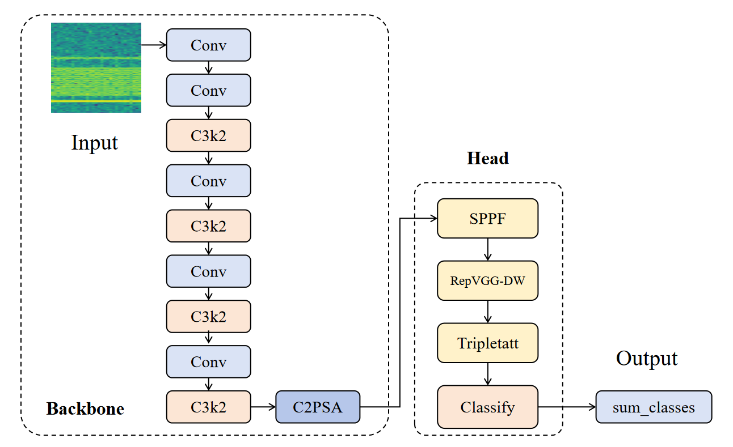
Figure 1. SRT-YOLO11 network model structure

SPPF module
The SPPF module is placed after the C2PSA output as the first part of the enhancement module layer. Its role is to enlarge the receptive field for features of different temporal widths and frequency spans, enabling the model to attend to both local details and larger-scale time-frequency structures. Shortwave signals may appear in spectrograms as narrowband continuous trajectories, burst segments, multi-tone structures, or wideband occupied regions, which are difficult to fully characterize with single-scale convolutions. Introducing a multi-scale pooling structure after high-level features therefore helps the model adapt to diverse spectrogram morphologies, as illustrated in Figure 2.
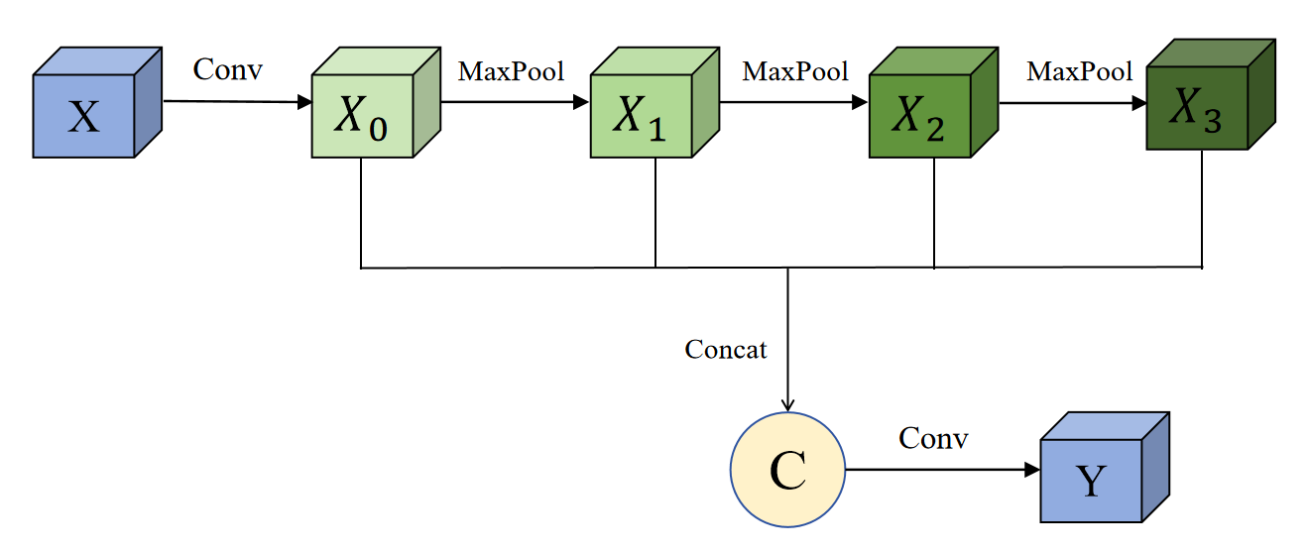
Figure 2. RepVGG-DW Module Schematic Diagram
SPPF originates from the idea of spatial pyramid pooling. He et al. proposed SPP-Net, which aggregates features at multiple scales through spatial pyramid pooling to enhance the adaptability of convolutional networks to scale variations [21]. In the YOLO family, SPPF can be regarded as a fast implementation of SPP, whose core idea is to approximate multi-scale context through serial max-pooling. Given the input feature F, SPPF first adjusts the channel number via convolution and then applies successive max-pooling operations:
$$F_{1}=MaxPool(F), F_{2}=MaxPool(F_{1}), F_{3}=MaxPool(F_{2})$$ | (14)
where F is the input feature map of the SPPF module, MaxPool(·) denotes the max-pooling operation, and $F_{1}$, $F_{2}$, and $F_{3}$ are the feature maps generated after one, two, and three successive max-pooling operations, respectively. The multi-scale features are then concatenated along the channel dimension and fused by convolution:
$$F_{SPPF}=Conv(\left[{F, F}_{1},F_{2},F_{3}\right])$$ | (15)
where $F_{SPPF}$ is the fused output feature of the module, Conv(·) denotes the convolution operation, and [·] denotes concatenation along the channel dimension. This step aggregates the original input feature with the multi-scale pooled features for feature enhancement. Without a significant increase in computational cost, the SPPF module enables the output feature to contain both the original local responses and contextual information at different pooling depths.

RepVGG-DW module
The RepVGG-DW module is placed after the SPPF module to further strengthen local time-frequency texture modeling. SPPF is mainly responsible for multi-scale context aggregation, whereas RepVGG-DW focuses on extracting local spectral textures, edge variations, and fine-grained energy distributions. The differences among shortwave signals in spectrograms often lie in local frequency spacing, burst boundaries, energy stripes, and subcarrier structures; therefore, adding a lightweight convolutional enhancement module after multi-scale features helps improve the model's sensitivity to subtle discrepancies, as shown in Figure 3.
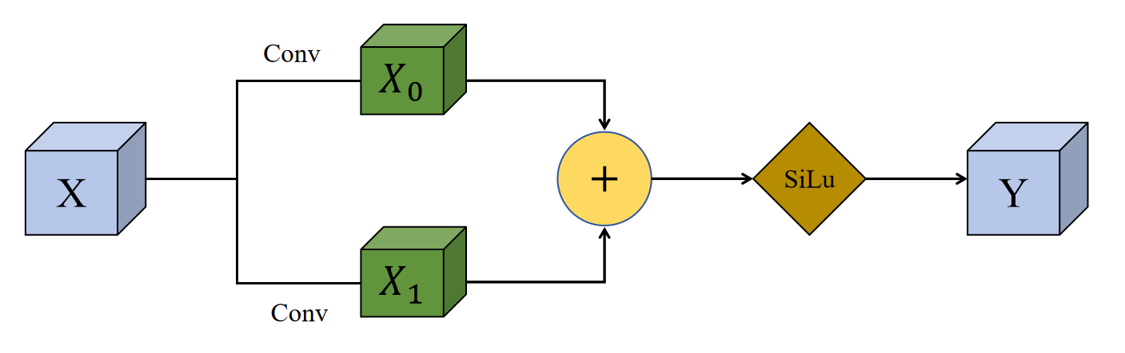
Figure 3. RepVGG-DW Module Schematic Diagram
The idea of RepVGG-DW is related to the structural reparameterization of RepVGG. Ding et al. proposed RepVGG, in which the multi-branch structure during training is equivalently converted into a single-branch convolutional structure for inference, thereby combining expressive training with efficient inference [22]. The core of structural reparameterization is that the 3×3 convolution branch, the 1×1 convolution branch, and the identity branch used during training are equivalently fused into a single convolution operator with merged kernels and biases at inference time.
In this work, RepVGG-DW adopts depthwise convolution for local feature enhancement. Compared with standard convolution, depthwise convolution performs spatial convolution independently for each channel, significantly reducing parameters and computation. Given the input feature F, the depthwise convolution of the c-th channel can be expressed as:
$$Y_{c}=K_{c}∗F_{c}$$ | (16)
where $Y_{c}$ denotes the output feature of the c-th channel after depthwise convolution, $K_{c}$ is the convolution kernel corresponding to the c-th channel, and $F_{c}$ is the c-th channel of the input feature map F.
Through depthwise convolution, the module extracts local spatial patterns within each channel without introducing massive cross-channel parameters. Combined with the multi-branch training idea of RepVGG, RepVGG-DW enhances local texture representation while remaining lightweight. In the proposed model, RepVGG-DW is located between SPPF and Triplet Attention: on the one hand, it receives the multi-scale contextual features from SPPF and further extracts local discriminative textures; on the other hand, it provides richer spatial responses for the subsequent Triplet Attention, enabling the attention module to more accurately select key channels and key time-frequency regions.

Triplet Attention module
The Triplet Attention module is placed after RepVGG-DW and before the classification head, serving as the last part of the enhancement module layer. Its main role is to perform cross-dimensional attention recalibration on the high-level features enhanced by multi-scale pooling and local convolution, so that the model focuses more on the channels, temporal regions, and frequency regions that contribute to classification, as shown in Figure 4.
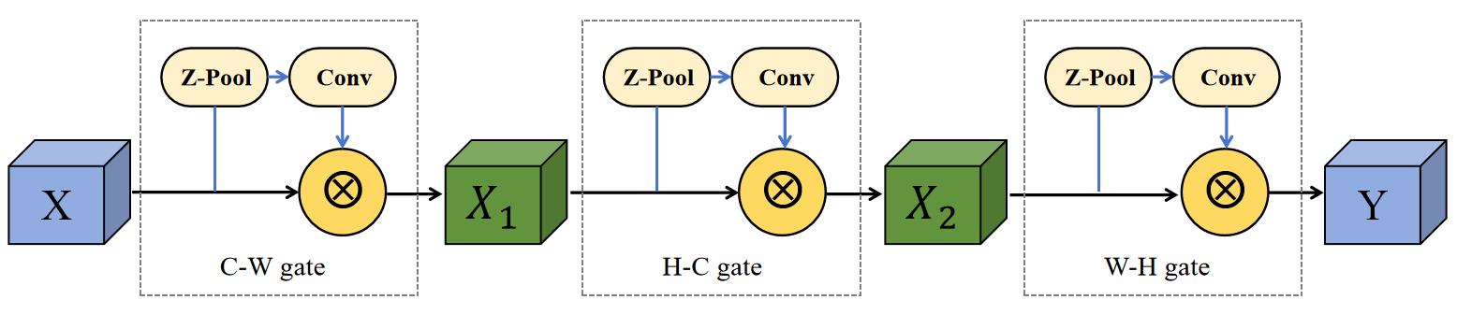
Figure 4. Triplet Attention Module Schematic Diagram
Conventional channel attention models dependencies only along the channel dimension, while spatial attention mainly focuses on two-dimensional spatial positions; however, the discriminative information in communication spectrograms often lies in the coupling among channel responses, temporal distributions, and frequency distributions. For example, some signal classes may share similar local textures but differ in the temporal persistence of energy or the extent of frequency expansion. Through rotation operations, Triplet Attention constructs three branches that model the interactions between channel and width, between channel and height, and between height and width, respectively, thereby enhancing cross-dimensional dependency representation [23]. Its input feature is:
$$F∈R^{C×H×W}$$ | (17)
where F denotes the input feature map of the Triplet Attention module, R^{C×H×W} denotes the three-dimensional real space in which the feature map resides, C is the number of channels, and H and W are the height and width of the feature map, respectively.
Triplet Attention transforms the features and computes attention through three branches. Each branch first applies a dimension transformation to the input feature and then aggregates average-pooling and max-pooling information via Z-pool:
$$Z(F)=\left[AvgPool(F), MaxPool(F)\right]$$ | (18)
where Z(F) denotes the pooled aggregation of the input feature F, AvgPool(·) and MaxPool(·) denote average pooling and max pooling, respectively, and [·] denotes the concatenation of the average-pooled and max-pooled results. Attention weights are then generated through convolution and a Sigmoid function:
$$A=σ(Conv(Z(F)))$$ | (19)
where A denotes the generated attention weight map, σ(·) is the Sigmoid activation function, Conv(·) denotes the convolution operation, and Z(F) is the aggregated feature obtained from average and max pooling.
Finally, the attention weights are multiplied with the original feature to obtain the recalibrated feature, and the outputs of the three branches are fused to form the final output:
$$F_{TA}=\frac{1}{3}(F_{cw}+F_{hc}+F_{hw})$$ | (20)
where $F_{TA}$ denotes the final output feature of the Triplet Attention module, and $F_{cw}$, $F_{hc}$, and $F_{hw}$ denote the outputs of the channel–width, height–channel, and height–width interaction branches, respectively.
In this task, Triplet Attention is located before the classification head and directly acts on the final semantic features. The advantage of this position is that, after the backbone, SPPF, and RepVGG-DW, the features already contain strong semantic and local texture information; introducing the attention mechanism at this stage can more effectively highlight key frequency bands, key temporal segments, and class-related channels while suppressing interference from noise backgrounds and non-discriminative regions on the classification decision. Therefore, Triplet Attention plays an important role in shortwave spectrogram classification under low-SNR conditions.

Results
To validate the effectiveness of the proposed SRT-YOLO11 model in shortwave communication signal classification tasks, this chapter presents analyses from multiple perspectives, including comparative experiments, classification performance evaluation, and ablation studies. The experimental dataset comprises nine categories of samples, namely 2G-ALE, 3G-ALE_BW0–BW4, CLOVER-2000, LINK11-CLEW, and BACKGROUND. Among these, the first eight categories are shortwave signals, while BACKGROUND represents background noise samples, serving to examine the model's capability to discriminate between valid signals and pure noise. Each signal type is acquired via its corresponding generator or noise collection procedure, then uniformly resampled to a 9600 Hz sampling rate with 4096 sampling points per segment, followed by amplitude normalization. Subsequently, additive white Gaussian noise is superimposed at specified signal-to-noise ratios (SNRs), and the resulting signals are transformed into time-frequency spectrograms via short-time Fourier transform as network inputs. To ensure class balance, each category contains 5000 samples, yielding a total of 45,000 samples across the nine classes, which are partitioned into training, validation, and test sets in a ratio of 7:2:1.
The proposed SRT-YOLO11 model is designed to enhance the anti-interference capability of spectrogram features under low-SNR conditions. Experimental results indicate that when the SNR falls below -20 dB, the recognition accuracy of all models approaches the level of random guessing; whereas above -2 dB, the performance tends to saturate, making it difficult to effectively distinguish improvements before and after modifications. Therefore, this chapter focuses on the SNR range from -20 dB to -2 dB, so as to more directly reflect the model's classification ability under severe noisy environments. The evaluation metrics adopt Top-1 accuracy, precision, recall, and F1-score, where Top-1 accuracy measures the overall classification performance, precision characterizes the correctness of predictions for a given class, recall reflects the proportion of true samples correctly identified, and the F1-score, as the harmonic mean of precision and recall, provides a comprehensive assessment of the model's recognition stability in multi-class tasks.

Comparative experiments
To comprehensively evaluate the proposed model, several representative lightweight classification networks are selected for comparison, including YOLOv8n-cls [24], ResNet18 [25], MobileNetV3-Small [26], ShuffleNetV2 [27], EfficientNet-B0 [28], ConvNeXt V2-Atto [29], and the baseline model YOLO11n-cls [30]. These compared models are all mainstream lightweight classification networks, covering various core lightweight strategies such as depthwise separable convolution, residual connection, and channel shuffle, and their parameter and computational scales are constrained by edge-deployment requirements while their inference speeds meet real-time application scenarios. All of them have been widely used in vision tasks and are suitable as the comparison basis for this study. Table 1 lists the parameter counts of each model together with the interval-averaged Acc and F1 over the -20 to -2 dB range.
As shown in Table 1, SRT-YOLO11 achieves the highest interval-averaged Acc and F1 with 1.72 M parameters. Compared with the baseline, the parameter count increases by only 0.18 M, while the interval-averaged Acc and F1 improve by 0.90 and 0.94 percentage points, respectively.
Table 1. Average performance comparison of mainstream lightweight models
in the [-20, -2] dB range
Model | Parameter quantity（M） | FLOPs  (G) | Inference delay/ms | FPS | Acc/% | F1/%
MobileNetV3-Small | 1.53 | 0.12 | 8.01 | 151 | 27.77 | 24.20
ResNet18 | 11.18 | 3.72 | 3.13 | 320 | 35.34 | 34.12
ShuffleNetV2 | 1.26 | 0.31 | 7.48 | 128 | 35.98 | 34.96
EfficientNet-B0 | 4.02 | 0.84 | 10.46 | 96 | 36.36 | 34.39
ConvNeXt V2-Atto | 3.39 | 1.12 | 7.38 | 136 | 35.82 | 34.52
YOLOv8n-cls | 1.45 | 0.84 | 6.34 | 238 | 35.77 | 34.50
YOLO11n-cls  (baseline) | 1.54 | 0.82 | 7.44 | 158 | 35.76 | 34.19
SRT-YOLO11(ours) | 1.72 | 0.86 | 9.18 | 128 | 36.66 | 35.13
Compared with other lightweight networks, SRT-YOLO11 also remains the best in terms of interval averages. Its Acc is 0.30 percentage points higher than that of the second-best EfficientNet-B0, and also exceeds those of ShuffleNetV2 (35.98%), ConvNeXt V2-Atto (35.82%), YOLOv8n-cls (35.77%), and YOLO11n-cls (35.76%); its Macro-F1 is 0.17 percentage points higher than that of the second-best ShuffleNetV2 (34.96%) and is clearly higher than those of EfficientNet-B0 (34.39%) and the YOLO-series baselines. It is worth noting that the parameter counts of EfficientNet-B0 and ConvNeXt V2-Atto are approximately 4.02 M and 3.39 M, respectively, both significantly higher than that of the proposed model, yet their interval-averaged Acc/F1 still do not surpass SRT-YOLO11; ResNet18, with 11.18 M parameters, does not outperform the proposed method in the low-SNR interval either. Although MobileNetV3-Small has a parameter count close to the YOLO scale, its interval-averaged Acc/F1 on this task is markedly lower, indicating that simply pursuing a mobile-oriented architecture does not necessarily translate into advantages for strong-noise spectrogram classification.
Overall, the advantage of SRT-YOLO11 lies in achieving the highest average accuracy and F1-score over the [-20, -2] dB SNR interval with a lightweight parameter overhead, striking a balance between accuracy and complexity rather than trading model size for gains. The above comparison demonstrates that the proposed SRT-YOLO11 outperforms existing mainstream lightweight networks in overall performance within the low-SNR interval.

Classification performance analysis
This section presents a detailed comparison between the proposed SRT-YOLO11 and the baseline YOLO11n-cls. The classification head of the baseline follows the structure C2PSA→Classify, whereas SRT-YOLO11 sequentially introduces SPPF, RepVGG-DW, and Triplet Attention before the classification head, yielding the structure C2PSA→SPPF→RepVGG-DW→TripletAttention→Classify. The average classification metrics of the two models over the -20 to -2 dB interval are summarized in Table 2.
Table 2. Classification metrics of the baseline model and the proposed model
over the -20 to -2 dB interval.
Model | Accuracy/% | Macro Precision/% | Macro Recall/% | Macro F1/%
YOLO11n-cls | 35.76 | 43.54 | 35.76 | 34.19
SRT-YOLO11 | 36.66 | 43.20 | 36.66 | 35.13
Improvement | +0.90 | -0.34 | +0.90 | +0.94
As shown in Table 2, compared with the baseline, the Accuracy and Macro Recall of SRT-YOLO11 both increase by 0.90 percentage points, while the Macro F1 increases by 0.94 percentage points. It is noteworthy that the Macro Precision exhibits a slight decrease, which can be attributed to the feature enhancement modules. The SPPF module enlarges the receptive field and incorporates more potential weak-signal regions into consideration, while the RepVGG-DW module strengthens local texture features, rendering these originally blurred weak signals more distinguishable on the feature maps. Consequently, during weight recalibration, the Triplet Attention module tends to preserve ambiguous samples located at the boundary between signal and noise. Although this mechanism leads the model to misclassify a very small number of strong noise samples as signals (a marginal decrease in Precision), it enables the recovery of a large number of weak signals that would otherwise be overlooked by the baseline (an increase in Recall). In shortwave spectrum monitoring, the consequence of missing a critical signal is substantially more severe than that of tolerating a limited number of false alarms. Therefore, this trade-off, in which a marginal increase in false alarms is exchanged for a higher detection rate, precisely demonstrates the enhanced capability of the proposed modules in perceiving weak signals.
To further investigate the recognition performance on individual categories, the per-class Precision, Recall, and F1-score are reported in Table 3.
Table 3. Per-class classification metrics of the baseline model and SRT-YOLO11.
Signal category | Precision/% |  | Recall/% |  | F1-score/%
Signal category | baseline | SRT  -YOLO11 | baseline | SRT  -YOLO11 | baseline | SRT  -YOLO11
2G-ALE | 80.69 | 73.85 | 56.83 | 62.18 | 59.91 | 64.04
3G-ALE_BW0 | 53.24 | 54.33 | 39.21 | 39.77 | 42.65 | 43.07
3G-ALE_BW1 | 35.73 | 33.98 | 25.29 | 26.23 | 29.18 | 29.33
3G-ALE_BW2 | 28.82 | 27.97 | 33.31 | 36.97 | 30.80 | 31.76
3G-ALE_BW3 | 37.57 | 40.64 | 32.63 | 28.44 | 34.38 | 32.73
3G-ALE_BW4 | 47.08 | 47.47 | 35.50 | 35.47 | 38.84 | 38.55
BACKGROUND | 36.09 | 37.92 | 74.58 | 71.91 | 42.60 | 43.10
CLOVER-2000 | 64.68 | 61.91 | 47.67 | 49.67 | 51.08 | 52.15
LINK11-CLEW | 78.96 | 81.53 | 59.86 | 59.67 | 63.55 | 64.13
As shown in Table 3, SRT-YOLO11 outperforms the baseline in terms of F1-score on the majority of classes, indicating a stronger comprehensive recognition capability and a more effective extraction of time-frequency structural features from shortwave spectrograms. For the 3G-ALE burst waveforms, the improved model achieves higher Recall and F1-score on BW0, BW1, and BW2. Since these waveforms share similar protocol structures and their features are readily submerged by noise at low SNRs, these improvements demonstrate that the proposed model possesses a stronger representation capability for subtle spectral differences. On the BACKGROUND class, the precision of the improved model increases from 36.09% to 37.92%, and the F1-score increases from 42.60% to 43.10%, reflecting an enhanced suppression of background noise and a reduced risk of misclassifying pure noise as valid signals. In conjunction with the overall improvements in Accuracy, Macro Recall, and Macro F1 reported in Table 2, it can be concluded that the combination of SPPF, RepVGG-DW, and Triplet Attention strengthens the feature representation of low-SNR spectrograms from three aspects, namely multi-scale context, local texture, and cross-dimensional attention, thereby improving the comprehensive classification capability for both shortwave signals and background noise.
To further illustrate the class-level classification differences between SRT-YOLO11 and the baseline (YOLO11n-cls), the row-normalized confusion matrices of the two models at -5 dB and -2 dB are provided. The vertical axis denotes the true class and the horizontal axis denotes the predicted class; each cell value represents the proportion (%) of samples of a given true class assigned to each predicted class. The diagonal elements correspond to the recall of each class, whereas the off-diagonal elements reflect the structural misclassification patterns. These two SNR points are selected because they are located in the transition region where the noise remains strong while the time-frequency structures begin to be separable; the resulting confusion patterns are therefore more indicative of the model's capability to discriminate fine-grained waveforms.
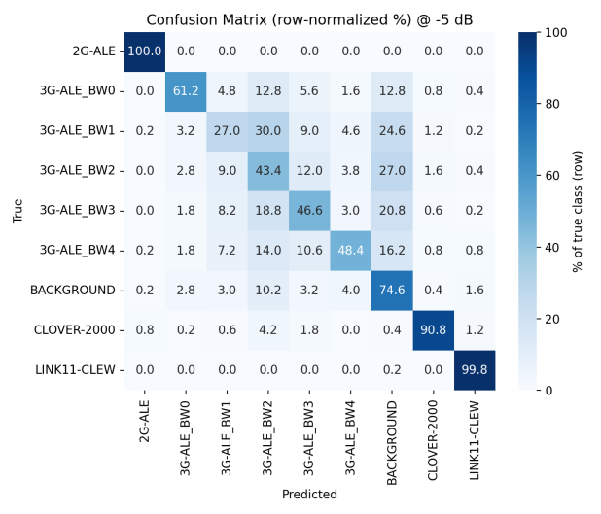 | 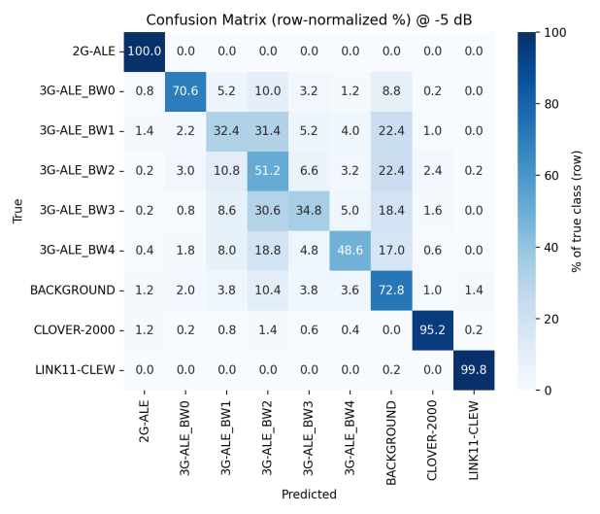
- Confusion matrix of the baseline model  at -5 dB | - Confusion matrix of the SRT-YOLO11 model at -5 dB
Figure 5. Row-normalized confusion matrices of the baseline model and SRT-YOLO11
at an SNR of -5 dB.
Figure 5 presents the confusion matrices at -5 dB. Specifically, the baseline recalls for BW0, BW1, and BW2 are 61.2%, 27.0%, and 43.4%, respectively, among which approximately 24.6% of BW1 samples are misclassified as background, indicating that the textures of narrowband burst waveforms are readily submerged under strong noise. SRT-YOLO11 increases these three recalls to 70.6%, 32.4%, and 51.2% (improvements of approximately 9.4, 5.4, and 7.8 percentage points, respectively), and the recall of CLOVER-2000 also increases from 90.8% to 95.2%. Correspondingly, the overall accuracy at this SNR point improves from 65.76% for the baseline to 67.27%. It should be noted that BW3 exhibits a local regression at this point (from 46.6% to 34.8%), suggesting that trade-offs among fine-grained classes persist and that the improvement is not monotonic across all subclasses; nevertheless, the model does not sacrifice global separability when evaluated on all nine classes.
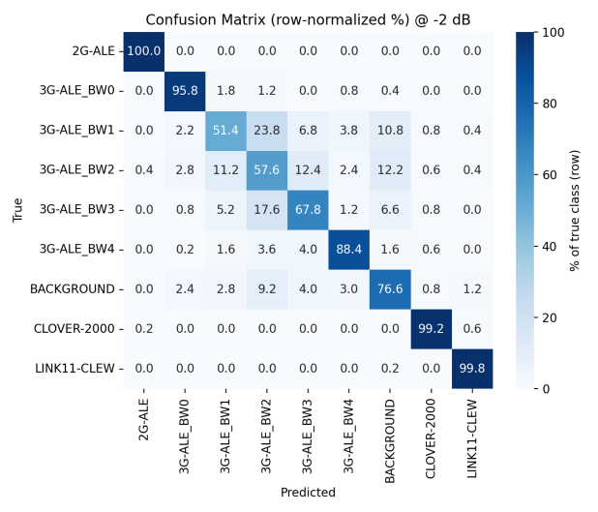 | 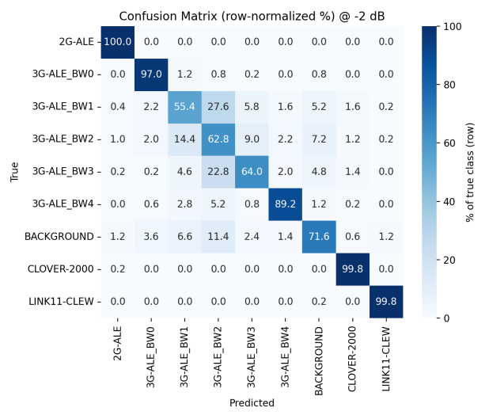
(a ) Confusion matrix of the baseline model  at 25 dB | - Confusion matrix of the SRT-YOLO11 model at -5 dB
Figure 6. Row-normalized confusion matrices of the baseline model and SRT-YOLO11
at an SNR of −2 dB.
Figure 6 presents the confusion matrices at -2 dB. With the increase in SNR, the diagonal responses of both models become more concentrated, whereas SRT-YOLO11 maintains its advantage on the difficult subclasses: the recalls of BW0, BW1, and BW2 improve from 95.8%, 51.4%, and 57.6% for the baseline to 97.0%, 55.4%, and 62.8%, respectively; CLOVER-2000 further reaches 99.8%; and the overall accuracy is 82.18%, compared with 81.84% for the baseline. A comparison of the two figures reveals that the main diagonal of the improved model is more concentrated, and the sidelobe leakage among the 3G-ALE subclasses and toward the background class is relatively attenuated, indicating that the progressive enhancement structure composed of SPPF, RepVGG-DW, and Triplet Attention contributes to strengthening multi-scale time-frequency representation and suppressing noise-dominated responses under medium-to-low SNR conditions. In summary, the confusion matrices verify from the class dimension that the advantage of SRT-YOLO11 is primarily reflected in the more robust recall of easily confused fine-grained waveforms, rather than in inflating the overall metrics through a small number of easily separable classes.

Case analysis
To illustrate how the proposed modules affect per-sample decisions, we examined individual 3G-ALE BW1 bursts at -5 dB, the class most susceptible to noise-induced feature submergence. In the evaluation reported above, the baseline misclassified 123 of the 500 BW1 test bursts (24.6%) as BACKGROUND, whereas SRT-YOLO11 restored 17 of these samples to the correct class and raised the class recall from 27.0% to 32.4%.
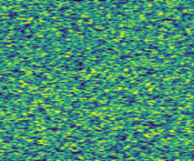  - 3G-ALE_BW1  -10dB | 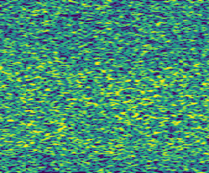  - 3G-ALE_BW1  -5dB | 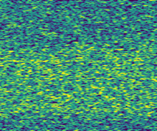  - 3G-ALE_BW1  -2dB | 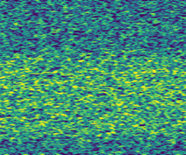  - 3G-ALE_BW1  0dB
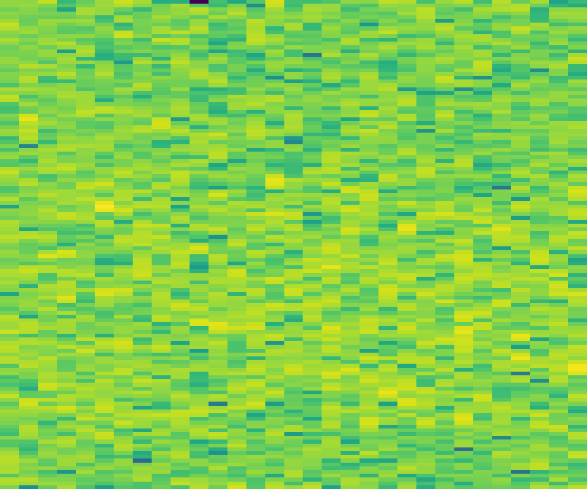  - Baseline →  BACKGROUND (0.62) |  | - SRT-YOLO11 →  3G-ALE_BW1 (0.73)
Figure 7. Case analysis of a representative 3G-ALE BW1 burst (test sample bw1_02594).
Figure 7 traces one such burst across SNR, chosen from the 17 recovered samples for its complete decision trajectory—correctly identified by SRT-YOLO11 from -5 dB upwards, whereas the baseline succeeds only from -2 dB. At −10 dB the burst is fully submerged in noise and is misclassified by both models; at -5 dB the baseline assigns the spectrogram to BACKGROUND with a confidence of 0.62 and allocates only 0.15 to the true class, whereas SRT-YOLO11 already identifies the burst correctly (confidence 0.73), indicating that the residual time–frequency ridge is better preserved by the multi-scale and local-texture modelling; at -2 and 0 dB both models are correct, with SRT-YOLO11 consistently more confident (0.996 versus 0.839 at -2 dB; 0.780 versus 0.664 at 0 dB). This per-sample trajectory corroborates the class-level statistics: the improvement of SRT-YOLO11 originates primarily from the recovery of narrow-band bursts whose time–frequency structure is submerged by noise, rather than from a redistribution of probability mass among classes that are already well separated.

Ablation study
To verify the contribution of each enhancement module, ablation experiments are conducted under identical data and training protocols. Taking YOLO11n-cls as the baseline, SPPF, RepVGG-DW, and Triplet Attention are progressively incorporated in the order from individual modules to two-module combinations and finally to the complete three-module model, and the corresponding variations in interval-averaged performance are recorded. The ablation configurations are listed in Table 4, and the results are presented in Table 5.
Table 4. Model configurations for the ablation study.
Number | Model | SPPF | RepVGG-DW | Triplet Attention
M0 | baseline
M1 | baseline+SPPF | √
M2 | baseline+RepVGG-DW |  | √
M3 | baseline+TripletAttention |  |  | √
M4 | baseline+SPPF+RepVGG-DW | √ | √
M5 | baseline+SPPF+TripletAttention | √ |  | √
M6 | RepVGG-DW+TripletAttention |  | √ | √
M7 | SRT-YOLO11 | √ | √ | √
Table 5 reports the interval-averaged accuracy of each configuration over the [-20, -2] dB range, together with the accuracies at several representative SNR points for a more detailed performance examination.
Table 5. Ablation results of overall accuracy (%).
Model | -20dB | -15dB | -10dB | -8dB | -5dB | -2dB | Average Acc
M0 | 11.98 | 14.60 | 31.91 | 46.20 | 65.76 | 81.84 | 35.76
M1 | 11.93 | 15.02 | 31.89 | 47.73 | 67.91 | 82.24 | 36.28
M2 | 12.13 | 15.02 | 34.60 | 47.80 | 66.24 | 81.69 | 36.69
M3 | 12.31 | 14.27 | 32.36 | 46.18 | 67.38 | 81.78 | 36.11
M4 | 11.82 | 13.60 | 29.33 | 45.13 | 66.82 | 82.42 | 35.05
M5 | 12.07 | 13.96 | 33.51 | 48.40 | 67.38 | 81.07 | 36.37
M6 | 12.40 | 14.89 | 32.80 | 47.18 | 67.73 | 82.00 | 36.56
M7 | 12.07 | 15.02 | 34.93 | 46.82 | 67.27 | 82.18 | 36.66
As shown in Table 5, the complete model (M7) attains an interval-averaged accuracy of 36.66%, corresponding to an improvement of 0.90 percentage points over the baseline. Among the single-module variants, the incorporation of RepVGG-DW alone (M2) yields 36.69%, which is essentially comparable to M7 and marginally higher by 0.03 percentage points, indicating that local texture enhancement provides the most direct contribution to accuracy. In contrast, the combination of SPPF and RepVGG-DW (M4) exhibits a noticeable performance regression (35.05%, inferior to the baseline), demonstrating that the enhancement modules cannot achieve gains through arbitrary stacking. On the whole, by integrating multi-scale aggregation, local characterization, and cross-dimensional recalibration, M7 establishes a more complete feature extraction framework and thereby exhibits superior robustness.

Discussion
Integrating the results of the comparative experiments, the classification performance analysis, and the ablation study, the following conclusions can be drawn. First, with approximately 1.72 M parameters, SRT-YOLO11 attains an average accuracy of 36.66%, which is 0.90 percentage points higher than that of the YOLO11n-cls baseline, and outperforms the compared models, including YOLOv8n-cls, ResNet18, MobileNetV3-Small, ShuffleNetV2, EfficientNet-B0, and ConvNeXt V2-Atto, indicating that the proposed architecture achieves stronger weak-feature recognition capability while remaining lightweight. Second, the per-class metrics and the Acc–SNR curves reveal that the improvement is mainly concentrated in the medium-to-low SNR transition region, where the model becomes more sensitive to weak time-frequency structures, and the macro-averaged recall and F1-score increase synchronously; although the precision decreases slightly, this behavior is more consistent with the practical requirement of not missing critical signals in spectrum monitoring scenarios. Third, the ablation results demonstrate that the enhancement modules cannot yield gains through arbitrary stacking, and the complete model achieves robust overall performance through the progressive combination of the three modules. In future work, structural optimization around the low-SNR interval will be further explored, and the generalization capability of the model in real shortwave channels and complex electromagnetic scenarios will be systematically verified.

Conclusion
This paper addresses the problem of shortwave signal spectrogram classification under low-SNR conditions and proposes SRT-YOLO11, an improved model built upon the lightweight YOLO11n-cls backbone that integrates SPPF, RepVGG-DW, and Triplet Attention. Multi-scale feature aggregation, local texture reinforcement, and cross-dimensional attention recalibration are successively introduced after C2PSA, so as to alleviate the submergence of time-frequency features by noise and the confusion among fine-grained protocols under low SNRs. On the nine-class task covering 2G-ALE, 3G-ALE (BW0–BW4), CLOVER-2000, LINK11-CLEW, and BACKGROUND, fixed-SNR sweeping experiments demonstrate that, within the
[-20, -2] dB interval, the proposed model attains an average accuracy of 36.66%, outperforming the baseline by 0.90 percentage points; compared with a variety of mainstream lightweight classification networks, the proposed model achieves superior comprehensive recognition performance with only a marginal increase in parameter overhead. The ablation experiments further indicate that the complete model obtains robust comprehensive classification performance through the progressive combination of multi-scale aggregation, local characterization, and cross-dimensional recalibration, which verifies the effectiveness of the proposed architectural design.

References
[1] Qu, Y., Lu, Z., Zeng, R., Wang, J. & Wang, J. Enhancing automatic modulation recognition through robust global feature extraction. IEEE Trans. Veh. Technol. 74, 4192–4207 (2025).
[2] Vagollari, A., Hirschbeck, M. & Gerstacker, W. H. An end-to-end deep learning framework for wideband signal recognition. IEEE Access 11, 52899–52922 (2023).
[3] Huynh-The, T., Huynh, P. T. & Pham, Q. V. Spec-YOLO: an efficient deep network for spectrogram-based signals identification. IEEE Wirel. Commun. Lett. 14, 3550–3554 (2025).
[4] Cao, J. et al. Recognition of common shortwave protocols and their subcarrier modulations based on multi-scale convolutional GRU. PLoS ONE 20, e0326536 (2025).
[5] Tang, N., Wang, X., Zhou, F., Tang, S. & Lyu, Y. Reparameterization causal convolutional network for automatic modulation classification. IEEE Trans. Veh. Technol. 73, 8576–8583 (2024).
[6] Dao, T. T. et al. VT-MCNet: high-accuracy automatic modulation classification model based on vision transformer. IEEE Commun. Lett. 28, 98–102 (2024).
[7] Shah, R. et al. A dual-stream convolution-GRU-attention network for automatic modulation classification. In Proc. 16th International Conference on Communication Systems & Networks (COMSNETS) 720–724 (2024).
[8] Oikonomou, T. K. et al. CNN-based automatic modulation classification under phase imperfections. IEEE Wirel. Commun. Lett. 13, 1508–1512 (2024).
[9] Jin, J. et al. Shortwave signal modulation recognition based on multi-scale depthwise separable convolution. In Proc. 7th International Conference on Information Communication and Signal Processing (ICICSP) (2024).
[10] Kay, B. et al. Permutation entropy for signal analysis. Discrete Math. Theor. Comput. Sci. 26 (2024).
[11] Scholl, S. Large-scale classification of shortwave communication signals with machine learning. Preprint at https://arxiv.org/abs/2504.05455 (2025).
[12] Huynh-The, T., Pham, Q. V., Vu, T. H., da Costa, D. B. & Hoang, V. P. Intelligent spectrum sensing with ConvNet for 5G and LTE signals identification. In Proc. IEEE Statistical Signal Processing Workshop (SSP) 140–144 (2023).
[13] Nguyen, G. V., Phan, C. V. & Huynh-The, T. Accurate spectrum sensing with improved DeepLabV3+ for 5G-LTE signals identification. In Proc. 12th International Symposium on Information and Communication Technology (SOICT) 221–227 (2023).
[14] Huynh-The, T., Nguyen, G. V., Vu, T. H., da Costa, D. B. & Pham, Q. V. SRNet: deep semantic segmentation network for spectrum sensing in wireless communications. IEEE Wirel. Commun. Lett. 14, 355–359 (2025).
[15] Nguyen, H. T., Dang, H. T. P., Pham, Q. V. & Huynh-The, T. Resolution-preserving multi-scale network for 5G-LTE spectrogram-based spectrum sensing. IEEE Wirel. Commun. Lett. 14, 1673–1677 (2025).
[16] Comar, B. Modulation recognition using YOLOv5 on the WBSig53 dataset. In Proc. 32nd Wireless and Optical Communications Conference (WOCC) 1–6 (2023).
[17] Kang, X., Chen, H. M., Chen, G., Chang, K. C. & Clemons, T. M. Joint detection and classification of communication and radar signals in congested RF environments using YOLOv8. In Proc. IEEE Military Communications Conference (MILCOM) 1–6 (2024).
[18] Quach, A. T. & Reese, R. D. YOLO for radio frequency signal classification. In Proc. IEEE International Symposium on Dynamic Spectrum Access Networks (DySPAN) (2024).
[19] Wang, X., Sun, S. & Zhang, H. Global context attention in YOLO for broadband signal identification. Electron. Lett. 61, e70358 (2025).
[20] Jiang, K., Peng, K., Feng, Y., Guo, X. & Tang, Z. DFN-YOLO: detecting narrowband signals in broadband spectrum. Sensors 25, 4206 (2025).
[21] He, K., Zhang, X., Ren, S. & Sun, J. Spatial pyramid pooling in deep convolutional networks for visual recognition. In Proc. European Conference on Computer Vision (ECCV) 346–361 (2014).
[22] Ding, X. et al. RepVGG: making VGG-style ConvNets great again. In Proc. IEEE/CVF Conference on Computer Vision and Pattern Recognition (CVPR) 13733–13742 (2021).
[23] Misra, D., Nalamada, T., Arasanipalai, A. U. & Hou, Q. Rotate to attend: convolutional triplet attention module. In Proc. IEEE/CVF Winter Conference on Applications of Computer Vision (WACV) 3139–3148 (2021).
[24] Jocher, G., Chaurasia, A. & Qiu, J. Ultralytics YOLOv8. GitHub https://github.com/ultralytics/ultralytics (2023).
[25] He, K., Zhang, X., Ren, S. & Sun, J. Deep residual learning for image recognition. In Proc. IEEE Conference on Computer Vision and Pattern Recognition (CVPR) 770–778 (2016).
[26] Howard, A. et al. Searching for MobileNetV3. In Proc. IEEE/CVF International Conference on Computer Vision (ICCV) 1314–1324 (2019).
[27] Ma, N., Zhang, X., Zheng, H. T. & Sun, J. ShuffleNet V2: practical guidelines for efficient CNN architecture design. In Proc. European Conference on Computer Vision (ECCV) 116–131 (2018).
[28] Tan, M. & Le, Q. V. EfficientNet: rethinking model scaling for convolutional neural networks. In Proc. International Conference on Machine Learning (ICML) 6105–6114 (2019).
[29] Woo, S. et al. ConvNeXt V2: co-designing and scaling ConvNets with masked autoencoders. In Proc. IEEE/CVF Conference on Computer Vision and Pattern Recognition (CVPR) 16133–16142 (2023).
[30] Jocher, G. & Qiu, J. Ultralytics YOLO11. GitHub https://github.com
/ultralytics/ultralytics (2024).

Author contributions
Shuo Xu: methodology, software, writing—original draft preparation, writing—review and editing; Jianxin Guo: resources, supervision, project administration; Rui Zhu: Conceptualization, methodology, resources, funding acquisition; Yushuai Zhang: visualization, validation; Feng Wang: resources, supervision; Yaru Li: writing—review and editing.
All authors read and approved the final manuscript.

Data availability
The datasets generated and analysed during the current study are available from the corresponding author on reasonable request.

Competing interests
The authors declare that they have no known competing financial interests or personal relationships that could have appeared to influence the work reported in this paper.

Funding
The Research Foundation for Talented Scholars of Xijing University under Grant XJ19B01.

